# **Problem Statement**

The goal of this project was to develop a predictive pricing model for Big Mountain Resort’s ski tickets. Given a dataset of 330 ski resorts, the objective was to recommend optimal ticket prices based on the resort’s features and compare these prices with other resorts, especially in Montana. The project further analyzed how operational scenarios, such as varying the number of open runs, would impact revenue.

# **Data Wrangling**

* Dataset Overview: Initial data included 330 rows and 26 columns covering resort attributes like lift types, terrain, and ticket prices.
* Missing Values: Significant missing data was found in columns like AdultWeekend and AdultWeekday ticket prices (~15% missing). fastEight had over 50% missing values and was dropped.
* Data Quality Issues: Issues such as duplicates (e.g., "Crystal Mountain" with two entries) were addressed, and outliers like "Silverton Mountain’s" incorrect terrain area were corrected. Categorical variables were validated for uniqueness.

# **Exploratory Data Analysis (EDA)**

* Geographic Insights: New York had the highest number of resorts, while Big Mountain Resort is in Montana (ranked 13th in terms of number of resorts).

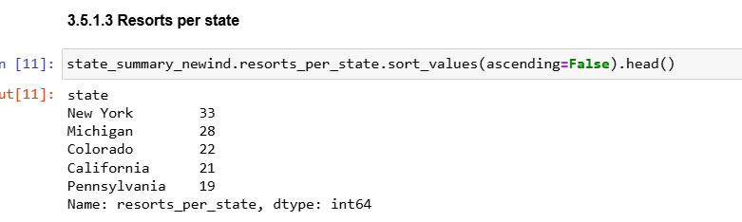

* Ticket Price Trends: Analysis showed that ticket prices varied significantly by state. Montana had lower ticket price ranges ($40-$50), while premium ski states like California and Colorado charged higher prices.

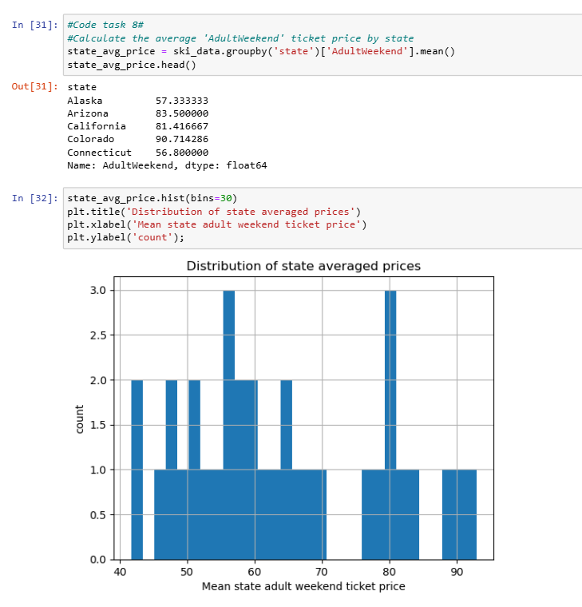

* Facilities: Big Mountain boasted unique features such as the highest number of runs, longest single run, significant skiable terrain, and multiple high-speed lifts.

# **Model Preprocessing with Feature Engineering**

* Target Variable: AdultWeekend ticket price was selected as the target for modeling due to fewer missing values.
* Feature Selection: Key features influencing ticket prices included skiable terrain, vertical drop, snowmaking capacity, and lift type (e.g., fastQuads).
* Data Splitting: Data was split into 70% training and 30% testing sets.
* Scaling: Standard scaling was applied to numeric features to normalize values.

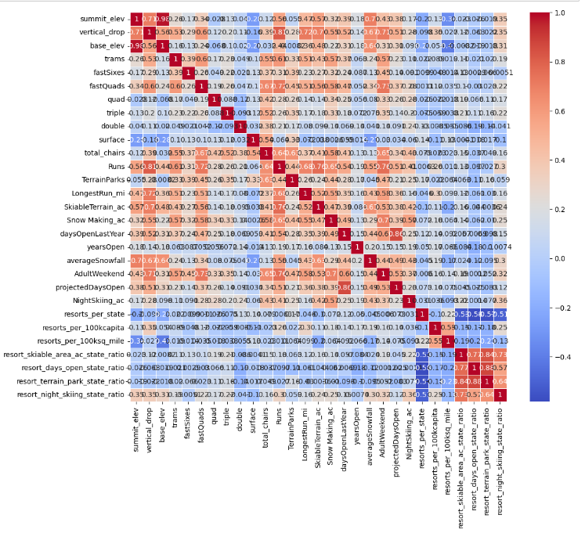

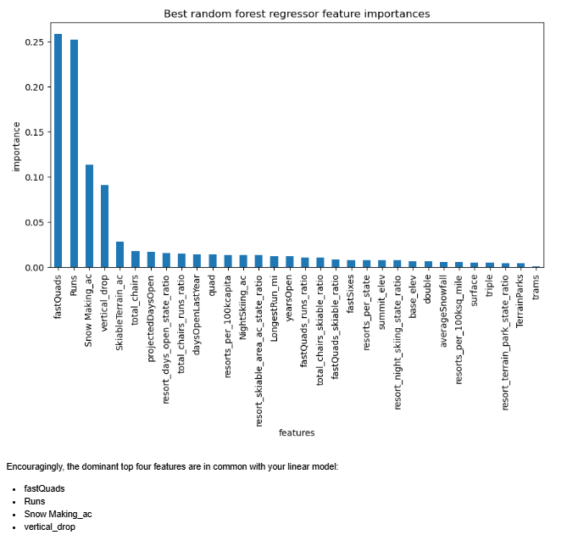

# **Algorithms and Model Evaluation**

* Algorithms Used: Multiple models were tested, including linear regression and random forest regression.
* Evaluation Metric: R² was used as the primary evaluation metric, measuring the proportion of variance in ticket prices explained by each model.
* Winning Model: The Random Forest model outperformed others with the highest R², accurately capturing the relationship between features and ticket price.

MAE for Linear Regression: 11.8

MAE for Random Forest Regression: 9.54

Random Forest Regression performs better

# **Scenario Modeling and Winning Model Insights**

* Scenario Analysis: Tested scenarios included:
  + Operational Impact: Closing 4-5 runs did not significantly impact revenue, while closing more than 6 runs resulted in revenue decline.
  + Facility Enhancements: Simulated the addition of runs, vertical drop adjustments, and snow coverage, which showed minor effects on revenue unless substantial improvements were made.
* Conclusion: Big Mountain’s current pricing reflects its facilities well, especially as the state’s premium resort. Minor facility changes alone would not justify price increases, whereas meaningful upgrades could support a higher ticket price.

# **Pricing Recommendation**

* Maintain $80 Weekend Ticket Price: This pricing is competitive, as most Montana resorts charge $40-$50, and Big Mountain's superior amenities justify its premium.

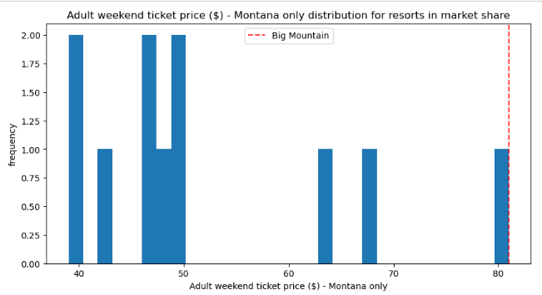

* Facility-Based Marketing: Emphasize features like high-speed lifts, extensive skiable area, and long runs to appeal to high-end consumers.

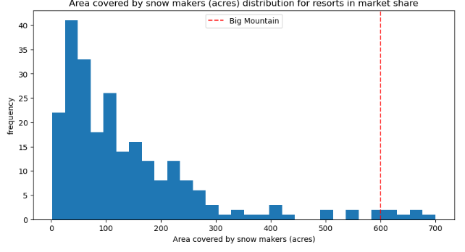 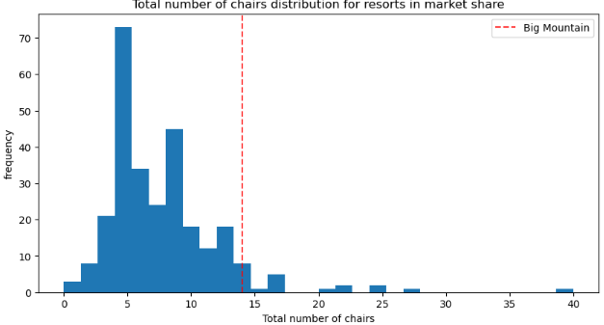 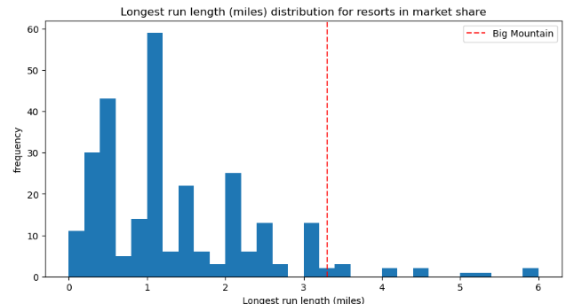

# **Conclusion**

Big Mountain’s ticket price is well-aligned with its amenities and state competition. For revenue growth, investments should focus on significant enhancements rather than incremental adjustments, and operational continuity should be prioritized.

Future Scope of Work

* Visitor Segmentation: Segment visitors by demographics to create targeted ticket pricing.
* Day Passes vs. Multi-Day Passes: Explore pricing strategies to attract different visitor types.
* Seasonal Price Adjustments: Analyze demand across peak and off-peak seasons to optimize ticket pricing dynamically.